**Case Keyword**

* Case keyword is a conditional JavaScript keyword label used with the **switch statement**. It contains a block of code which is executed only when the switch value matches with the case code.
* A switch statement can contain multiple case labels each case label must hold a different value.
* The case label can contain [Break Keyword.docx](Break%20Keyword.docx) that stopped the flow of the execution.
* The case does not hold the value of Boolean, float and double type.

Syntax of case keyword is:

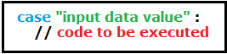

* **Remember:** input data value is a changeable value depends on the inputted value from “prompt” or “date”….etc.
* Cases with the same code were written with only single code.
* If there is more than case with the same statement then the first top case will be executed.

